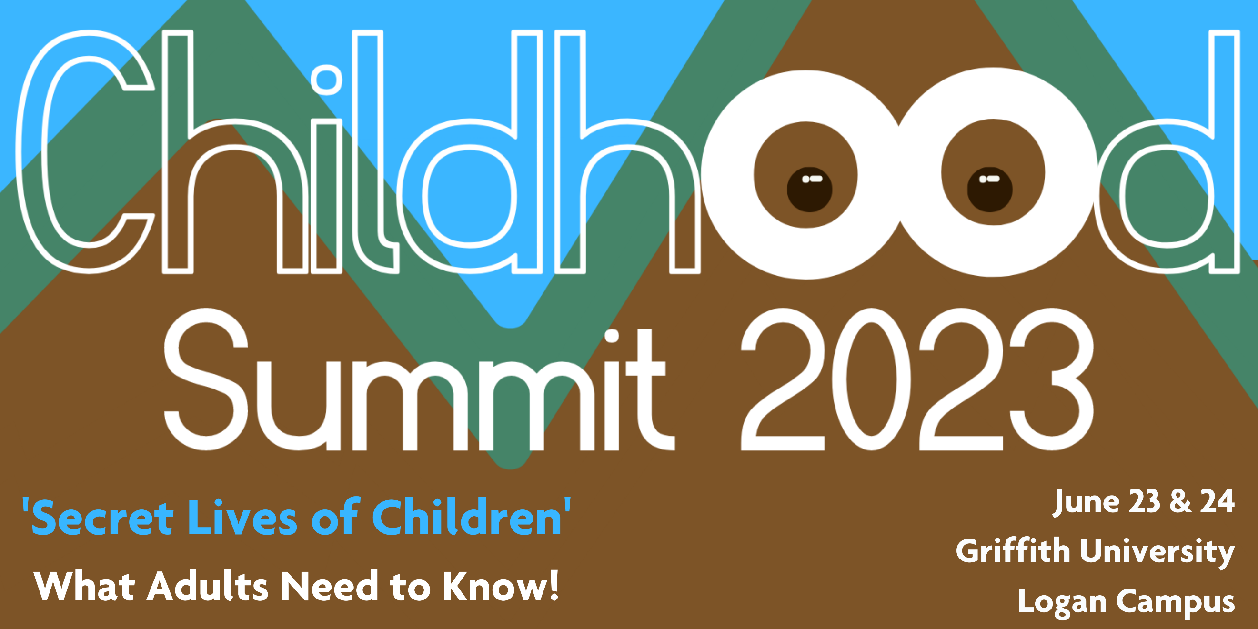2023 Child’s Voice Application

WE NEED TO HEAR WHAT IS IMPORTANT TO YOU!
Send a 2min video telling us what you want to say.

A lot of us grown-ups are very concerned for today’s children. We are worried that us grown-ups might be changing all the best parts of being a child.

We would like to hear directly from you. Young people (3 to 14yrs or younger).

All child voice applications films will be used to deliver messages to grown-ups and promote what you want to say.

40 of these applications will be the chosen to be ‘The Voice of Childhood’ and represent children in at the National 2023 Childhood Summit, June 23 & 24 at Griffith University Logan Campus

The young persons selected to be the ‘Voice of Childhood’ will receive:
- Opportunity to deliver presentation (up to 10min) at the 2023 Childhood Summit in Logan to an audience of up to 250 very interested grown-ups who work with children.
- Video recording of your presentation to keep.
- Speaker’s fee of $220 (inclusive of GST)

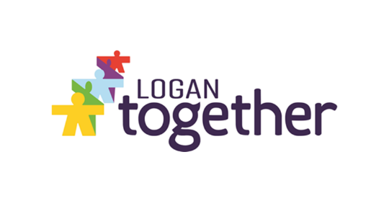
Child Voice Speaker Fees have been generously sponsored by Logan Together

This is your chance to say what is important to you and have your voice heard.

Some questions to get your ideas going:

What does it mean to be a young person in Australia? What are your concerns?

As a child growing up, what is important to you in your community or neighbourhood?

If you could be the ‘Change-Maker’ what would you change?

Are there things you see you are not happy about? Do you need help?

If you could make changes to your neighbourhood, or community, or school, or your environment, what would you suggest?

Children and Play: Tell us about the way today’s children play?

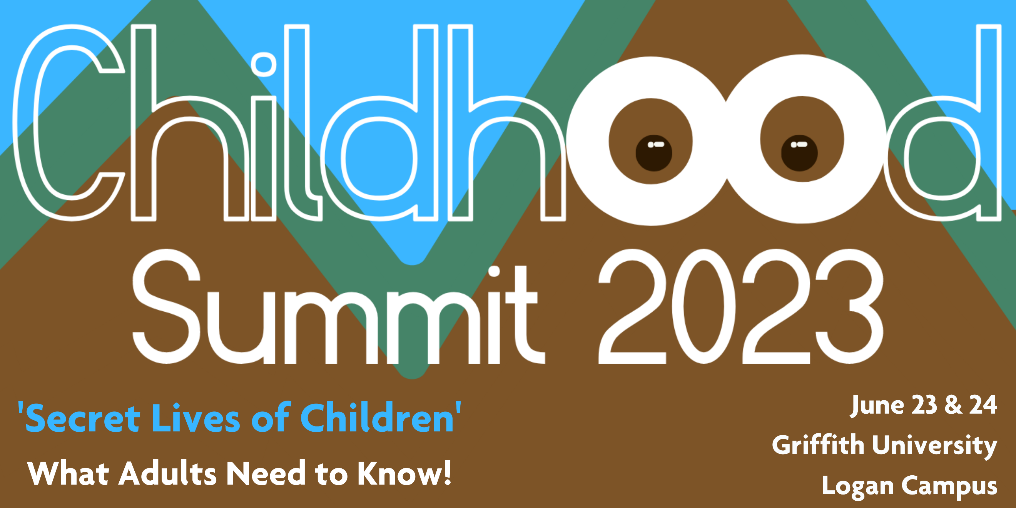
Child’s Voice Application Form

Name: ______________________________________

Phone: ______________________________________

What area of Logan do you live in? ____________________________________________

- Brainstorm your ideas, what you would like to say?
Filming Tips:

- Use landscape format
- Keep the phone or camera steady
- Check the mic volume is turned up
- Film in a sunny or bright spot
- Have fun!

- Record your video (1-2mins)
It doesn’t need to be fancy – but feel free to be creative - explain what is important to you. What you would you like to say?

- Have your guardian or parent complete media consent form attached (if you have friends in your film, their guardians or parents need to complete and sign a form as well).

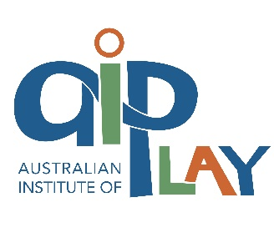
- Ask your parent or guardian to email your film and consent form via dropbox (or other file sharing platform) by 5pm 20th of April, 2023: hello@australianinstituteofplay.org (please contact Hyahno 0403 458 871 or Jordan 0412 467 304 if you need support submitting your application).

Thanks for being involved. We will let you know if you are successful on May 9th, 2023.

